Group 1

**Memorandum**

To: Teneleer Tivan, Vice President,

Videoconferencing Acquisitions, Illinois State University, Normal, IL

From: Group 1

cc: Prof. James Wolf

Date: 09/14/2020

Re: Zoom vs. Microsoft Teams vs. Google Meet: Which Top Videoconferencing App is best for Illinois State University?

In this project, with the combination of interviews of many people from different people belonging to different professions(students, workers and professors) and the practical manoeuvres by all the team members of the group, we reached to the conclusion that ‘Zoom Meetings’ maybe suggested to be a better option against the other two video conferencing apps. We reached this conclusion through a series of tests and interviews described as follows.

Practical Manoeuvers:

Putting our hands on all the three apps helped us learn much more about these apps, such as:

The Zoom meeting took some effort. Participants had to wait until the host started meeting. Everyone could enable/disable their microphone and camera. It also gave us some information about other participants’ connectivity. It also has other special features like virtual background, virtual breakout rooms, virtual white board and Participant Reporting feature.

Google meet is quick when it comes to setting it up and joining. Just like zoom, here also, participants can turn off their audio and video before entering a call. Also, some important features of Google meet include viewing the 10 most active participants as well as being able to send text messages through the interface.

Microsoft allows a team to jump on a call from a text message thread. It also allows screen sharing and video call recording, just like the other two, but inviting an external participant who is nota part of the team requires some extra steps.

Here are some pictures of our hands on all these apps:

# Zoom:

|  |  |  |
| --- | --- | --- |
|  |  |  |
| Video Conferencing | Virtual Board | Screen Sharing |

**Google Meet:**

|  |  |
| --- | --- |
|  |  |
| Video Conferencing | Screen Sharing |

|  |  |  |
| --- | --- | --- |
|  |  |  |
| Video Conferencing | Scheduling through Calendar | Quick Dials |

**Microsoft Teams:**

Interview Summary:

Over the course of this investigation several interviews were conducted with various members of faculty, students on campus, and professionals in the different industries. While the majority of those interviewed used zoom for various academic, professional, and social related meetings, a few used applications such as Microsoft Teams and Discord. During the interviews it was revealed that few had problems working with zoom and felt that it was a benefit to their instruction/business during the current public health crisis. Dr. Su of the ISU Physics Department did bring up some desires for better features related to lecture settings and stated he was using several lecture/white board apps in conjunction with zoom during his work. Some students felt that in-person lectures were still the most effective learning environment but had little complaints about the applications themselves.

Team Contribution:

Ultimately each team member independently contributed a portion of this assignment to the whole. Each team member reached out the minimum of two interviewees in order to get feedback, and each team member tested the various recommended video conferencing applications. James Brokaw set up the meetings and delegated tasks on zoom to better organize our efforts and wrote the first paragraph pertaining to the interview summary. Eric Agyemang contributed by writing the second paragraph and worked closely with the other team members in order to determine the criteria that we would rate these applications. Divya Bhadoriya took each team member's individual ratings for these applications and averaged the scores in order to determine which of the three would be our recommendation. Sagar Barvaliya wrote the summary of the tests of each platform, and organized the final memo to present this information.

Project Selection Matrix:

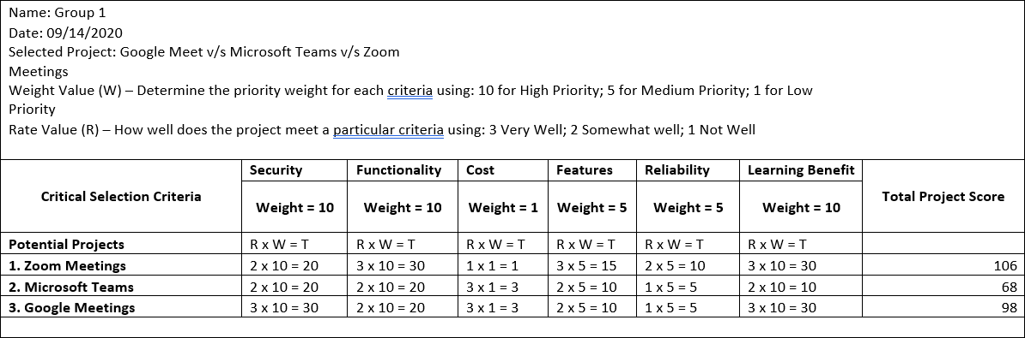

Summary of the Project Selection Matrix:

In this matrix, there are six critical selection criteria, namely, security, functionality, cost, features, reliability and learning benefit. Amongst them, Security, Functionality(ease of usage) and learning benefits are highly prioritized, whereas, cost of the app was least prioritized. Features and reliability are important, but the reason they are moderately prioritized is because institutional use of these apps does not require too many features. In case of security, google leads the other two apps as it provides cloud storage in Google drive, whereas ‘Zoom Bombing’ and other participant’s control access defines the security issues in other two apps. Easy to use the zoom app gives it the highest priority on functionality basis, whereas, sophisticated process of inviting a non-member of the group decreases a point for microsoft teams. Zoom subscription is comparatively higher than the other two apps, hence, low rate value of zoom. Other than scheduling a meeting or screen sharing in all three apps, zoom provides various additional features like a virtual board, which is very useful for professors to teach students. Therefore, zoom is given highest priority in terms of features. Most of the universities and businesses relies on zoom rather than the other two. Microsoft is mainly used for businesses hence provides few educational features, whereas virtual white board and breakout rooms by zoom and ease of use of various google apps help students learn a lot while attending a meeting.

In a nutshell, we can see that based on these six criteria essential for educational purpose, Zoom meeting wins the race and can be best suited for our university at the moment.

Eric Agyemang